STOCK MARKET PREDICTION USING MULTI-SOURCE MULTIPLE INSTANCE LEARNING
Scope and Limitations
Department of Computer Science and Engineering, [COLLEGE NAME]
Batch C4 (CSE-C) · Academic year [ACADEMIC YEAR]
Table 1: Project team
S.No. | Student name | Roll number
1 | Pottepaka Lingaswamy | 23K91A05J7
2 | Maduna Naveen Kumar | 23K91A05D7
3 | Meedigeri Keerthi | 24K95A0517
4 | Mareddy Sai Karthik | 23K91A05E8

Project guide: K Anusha
Chapter and section numbers quoted in the text (for example Chapter 8 or Section 6.2) refer to the full project report, 17.Final Document. Figures and tables in this document are numbered from 1.

1. SCOPE

1.1 In scope
• Short-term forecasting of closing prices for a configurable universe, default ten tickers (TSLA, AAPL, AMZN, MSFT, GOOGL, NVDA, META, FDX, IBM, ORCL): 5-day and 30-day horizons with a 95 % band and an up/down trend flag.
• A comparison of nine models on a chronological 80/20 split: ARIMA, SARIMAX, Prophet, Random Forest and SVR as baselines, and LSTM, LSTM plus attention, plus sentiment, and a simulated-federated hybrid as deep tiers.
• Headline sentiment: NewsAPI headlines scored by FinBERT-tone when a key is set; otherwise a labelled synthetic-headline fallback with the same schema.
• A website and API: dashboard, forecast, model comparison, news sentiment and method screens over seven endpoints, in light and dark themes.
• Evaluation work added for the documents: five-seed re-run, persistence baseline, forward test, API latency, tests, and an offline MIL study on real headlines.

1.2 Out of scope
• Multiple instance learning inside the application, and any social-media text source: neither exists in QuantPulse.
• Precision, recall and F1 in the application: it forecasts price levels, not a direction classifier (the offline study reports them).
• Trading, order placement, portfolio construction, transaction costs and back-tested strategies; QuantPulse is a research and education tool, not financial advice.
• Intraday data, options, other asset classes, macro-economic indicators and technical indicators beyond the five OHLCV columns.
• User accounts, a database, role management, multi-tenant operation and cloud deployment (there is no login and no database).
• A real federated deployment: all ten clients run in one process and exchange weights in memory.

1.3 Boundaries of the product
Table 2: Dimensions of the delivered system
Dimension | Delivered
Universe | 10 tickers (override with QP_TICKERS); 501 daily rows each (2024-09-09 to 2026-09-08 for the shipped artefacts)
Models | 5 baselines, LSTM(64), LSTM(64) + 4-head attention, sentiment variant, FedAvg hybrid (10 clients x 2 rounds x 3 epochs)
Window and split | 20 trading days; chronological 80/20; Min-Max scaling fitted on the first 80 % of rows
Horizons | 5 and 30 trading days, recursive; band = 1.96 x residual std x sqrt(h)
Interface | React 19 + Vite, 6 routes; FastAPI, 7 JSON endpoints; ports 5404 and 8404
Sentiment | FinBERT-tone (yiyanghkust/finbert-tone) on NewsAPI headlines, or synthetic template headlines
Hardware used | Intel Core i5-12500, 15.7 GB RAM, no GPU; one full re-run of five seeds took 34 minutes

2. ASSUMPTIONS
The results depend on the following assumptions, all of which are choices of the project or of the base paper rather than findings.
• Data. Daily Yahoo Finance bars are taken as correct; the unadjusted Close is used as the target; the last two years are enough history; the same 20-day window suits every ticker.
• Split. A chronological 80/20 split with Min-Max scalers fitted on the first 80 % of rows is a fair test; the deep tiers hold out the last 15 % of the training windows for validation and early stopping (patience 7).
• Sentiment. A headline's FinBERT tone (positive +1, negative -1, neutral 0, times its probability) averaged over a day represents the market mood; the daily value is carried forward over days without headlines and is zero before the first headline.
• Federation. Each ticker is one client; clients start from one global model, train for three epochs, and their weights are averaged in proportion to sample count; two rounds are enough.
• Forecast. For multi-day horizons the predicted close is fed back as the next day's Open, High, Low and Close; volume and sentiment are held at their last values; the band grows with the square root of the horizon.
• Evaluation. Directional accuracy compares the sign of the predicted close minus yesterday's actual close with the sign of the real change; the re-run adds true-target scoring, persistence and five seeds (42-46).
• MIL study. A headline belongs to the bag of the first trading day whose close is not earlier than its time stamp (day-level stamps go to that calendar day); the label is whether the next close is higher; the instance vector is three FinBERT-tone probabilities plus 64 PCA components of the [CLS] vector fitted on training headlines only.
• Operation. One user, one machine, internet access for Yahoo Finance, and no authentication.

3. LIMITATIONS
The limitations below are properties of the delivered system and of the evidence, ordered by how much they affect the conclusions.
Table 3: Limitations of QuantPulse and their effect
Limitation | Evidence | Effect on the conclusions
No multiple-instance learning, social media or P/R/F1 in the product | Sentiment is one daily mean per ticker; the attention layer runs over the price window | Objectives 3 and 5 are met only by the offline study
Sentiment is synthetic in the shipped run | News source 'synthetic-fallback' for all ten tickers; 183 template headlines for TSLA, generated for the last 90 days only | The sentiment tier says nothing about real news
Sentiment channel is zero throughout training | 0 non-zero rows in the training part of every ticker; 83-90 in the test part | Sentiment tier MAE $37.55 ± 7.69 against $29.37 without it
Test targets are clipped to the training range | 5 of 10 tickers have more than half of their test closes above the training maximum | Shipped direction 68.3 % against true 53.0 %; MAE understated
Deep tiers do not beat persistence | Persistence MAE $6.24; best tier $29.37; R2 -3.5 on real closes | The product forecasts are not useful as price levels
Stored forecasts missed the realised moves | 5-day mean forecast -14.8 % vs actual -0.4 %; trend right for 4 of 10 | 9 of 10 tickers were flagged 'down'
FedAvg across differently scaled clients | Hybrid MAE $43.70 ± 11.14 on real closes | Federation did not help; the base paper's gain is not reproduced
Artefacts older than the data | Trained on data to 2026-09-08; CSVs overwritten by every live pull | The Forecast screen shows a banner; retrain to refresh
Small, short data | 501 rows per ticker; 97 test windows | Single-split results are noisy; seed std up to $11.1
Mixed baseline protocols | ARIMA/SARIMAX/Prophet forecast 101 days without refitting; RF/SVR use actual lags | Baseline table is not like-for-like (as in the base paper)
MIL study is small | 7 tickers, 2022-2023, 1,309 test samples; stamps day-level | Differences under about 3 accuracy points are noise
CPU only, one machine | i5-12500, no GPU | No large-scale or hyper-parameter search
No authentication, no database | No login route; state is JSON/CSV/Keras files | Not a production service

Further defects of the shipped code, kept unchanged in this project: multi-step forecasts roll the Close forward and overwrite Open, High and Low with it; the synthetic fallback seeds with Python's hash(ticker), so its headlines change between processes; the API never loads the saved .keras models and serves stored JSON; the stored 5-day forecast comes from the federated model while the 30-day forecast comes from the local attention-plus-sentiment model.
Two figures show the limitations that matter most for reading the numbers. The first shows, for each ticker, how much of the test period lies above the highest price seen in training and how the directional accuracy that the application reports compares with the accuracy measured against the real closes: where the target is clipped the reported figure is inflated. The second shows the sentiment channel: it is exactly zero for every training row and carries values only in the test part, because the fallback headlines are generated for the last 90 trading days only.
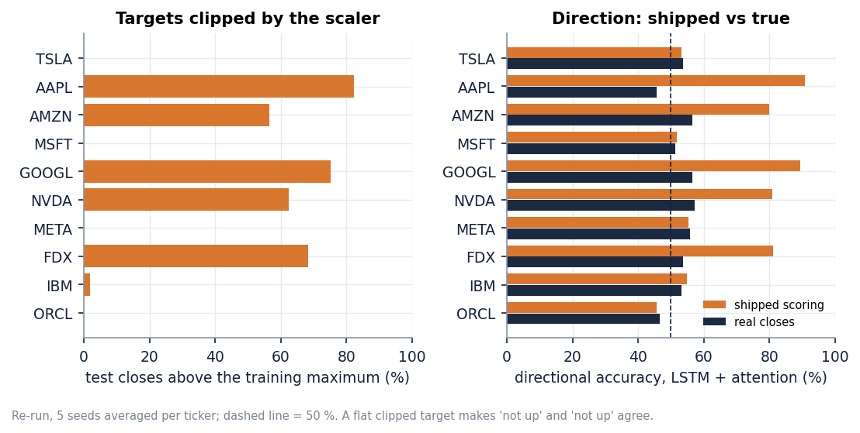
Figure 1: Share of test closes above the training maximum, and directional accuracy as shipped and as measured against the real closes.
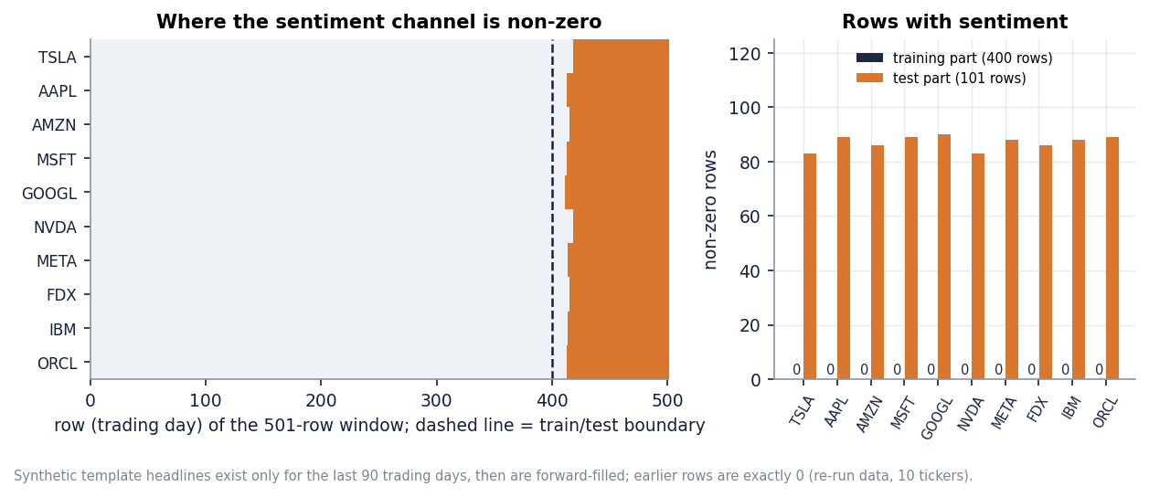
Figure 2: Non-zero sentiment rows in the training and test parts for each ticker, and the TSLA sentiment channel over time.

4. WHAT WAS NOT MEASURED
The following were not measured, and nothing in the documents should be read as a result for them:
• Real NewsAPI headlines inside the product (no key was available), and any social-media text (no data source was available).
• Multiple instance learning, precision, recall and F1 inside the application; they exist only in the offline study.
• Trading performance, transaction costs, risk-adjusted returns or any back-tested strategy.
• A genuine federated deployment: communication cost, privacy guarantees and client drop-out were not studied because the federation is simulated in one process.
• Behaviour under concurrent users, long-running stability and memory footprint; GPU timing; energy use.
• A clean-machine run.bat install and the Docker image (Docker was not used).
• Security of the API (no authentication exists) and browser compatibility beyond Chromium and Chrome.
• News effects at scale: the MIL study covers seven tickers, two years of dense headlines and 1,309 test samples; GOOGL, META and IBM had no usable headlines.

